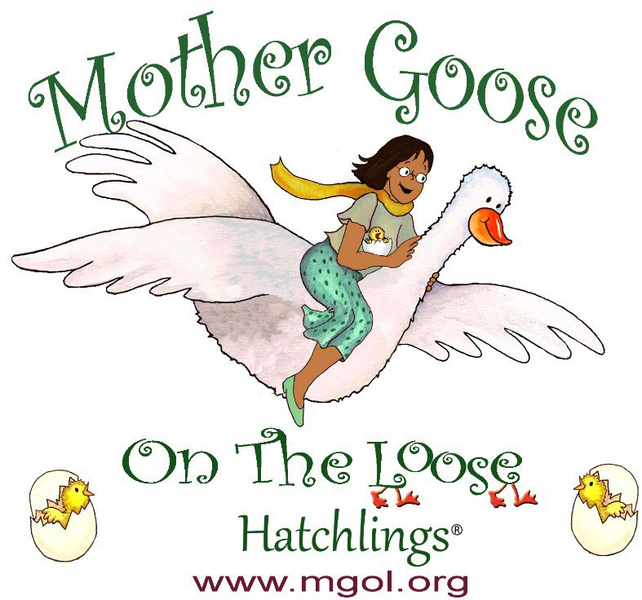

**Thanks for coming to *Hatchlings, In the Nest*! Please complete the follow-up survey.**

QR Code for Surveys in English QR code for surveys in Spanish



The MGOL Hatchlings materials were developed for the Maryland State Library Agency with funds from the Maryland State Department of Education, Division of Early Childhood, as part of the PDG Birth-5 funds through Grant Number 90TP0032-01-00, from the Office of Child Care, Administration for Children and Families, U.S. Department of Health & Human Services.