RTH Script

**Before the session**

Welcome! So glad you could make it to our Ready to Hatch class. Would you prefer materials in English or Español?

Please **sign-in on our list**, complete a **consent form**, and make a **name tag**. If you need an explanation of anything, let us know. We’ll be happy to answer your questions. Then, find a seat in the circle.

*Handout bundles per household*

*Review consent forms for photo permissions*

(Signing the Consent to Participate form gives us permission to ask you questions and use your answers in a program evaluation we are doing on this Ready to Hatch class. It’s very new, so we’d love to find out what you think about it and if you’ll use any of these practices at home. The form also gives permission to take photos and videos to document and develop the session, but we will not use your name unless you give us specific permission for that.)

(If a few participants today do not want to be in photos and that is fine. Please move to the side of the circle so we can safely take pictures of the group without catching you.)

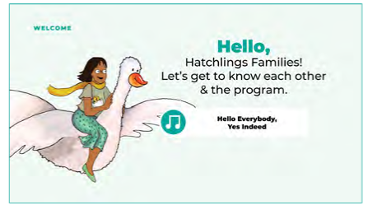**PANEL 1: Welcome**

Hello moms, dads, parents, and all our caregivers with us today! Welcome to Mother Goose on the Loose Hatchlings Ready to Hatch, and thank you for joining us. I’m EMILY, a children’s instructor here at the Elkridge Branch of Howard County Library System.

My colleague in the children’s department here at ____branch____, _____colleague______, is here with us. And _____interpreter_____ is here today as our Spanish interpreter.

I’m delighted to see you all here today. Has anyone here been to a Hatchlings class already?

Let’s go around the circle, one by one. Would each person please tell us your name and just one quick sentence about why you are here today? For instance, “I’m excited about becoming a parent,” or “This is our third child.” We’ll have more time to get to know each other at the end.

*”Welcome ____” each by name*

Once again, I’m EMILY and thank you for joining today. **Our class today is about EARLY LITERACY.** You may have heard the phrase “Early literacy begins at birth,” but that’s not really true. Early literacy begins BEFORE birth! By coming here today to learn about ways to support your baby’s development even before birth, you’re giving your child a big head start.

Let’s start today with a song – you'll see that singing is going to be a theme today 😊

**It’s called “Hello Everybody, Yes Indeed”** ***“Hola, todos, sí, sí, sí”***

**Hello, everybody yes indeed,** ***Hola, todos, sí, sí, sí***

**Yes indeed, yes indeed.** ***Sí, sí, sí. Sí, sí, sí.***

**Hello, everybody yes indeed,** ***Hola, todos, sí, sí, sí***

**Yes indeed my baby.** ***Sí mi amor, mi niño.***

**Program Info:** This Ready to Hatch class was created by the Maryland State Library especially for expectant parents like you. We’re going to sing songs, recite rhymes, and read aloud here today.

Raise your hand if you are a professional singer. I’m not 😊 Sometimes I sing off-key. But I still sing to children all the time and they don’t mind.

**To your baby, your voice is the best voice ever.** Singing to your baby is a gesture of love, and they love it. Studies show that **singing and sharing books aloud helps a baby’s brain development and health even before they are born**. Hearing the words and voices actually builds baby’s brain!

That’s why we hope you’ll **join in singing, rhyming and reading today**, and **continue at home even before baby is born.**

**Gift Bundles:** We have a lot of great information for you today, but no need to take notes. You have **gift bundles!** I’ve given one to each household. There’s a **flyer of the colorful panels** from our presentation as reminders of what we talk about today. Everyone also takes home two **board books**, a **song sheet**, a **yearlong activity calendar**, and several **resources from the library (booklist, class calendar, etc)**.

Hatchlings is a new program so it’s especially wonderful that you are here. To make this class its best, we’ll be requesting your feedback with a quick **paper survey** at the end of the session. Thanks in advance for helping us this way.

Let’s dive in!

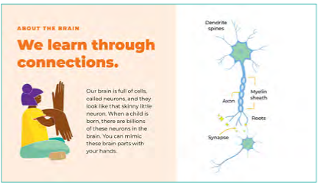**PANEL 2: Brain Diagram**

**First let’s talk a little about the brain and how it works.**

Our brain is full of cells, called **neurons**, and they look like that skinny little tree-shaped neuron (point to panel). When a child is born, there are billions of these neurons in the brain.

I’m going to show how they work using my hands and arm. *Put wrist of one hand on the bent elbow of the other with fingers facing down. Wiggle bottom fingers.* The part at the bottom that looks like the tree roots – those are the **dendrites.** The dendrites send signals to other neurons.

The tree trunk part is called the **axon**. *Rub lifted arm.* The axon transmits signals between the bottom of the neuron and the top.

At the top, we have the **cell body. \***Show palm.* The branch-like parts coming out of the cell body are the **dendrite spines. \***Wiggle top fingers.* The dendrite spines receive and respond to signals from other neurons.

Each time the dendrite spines of one neuron connect with the roots of another neuron, a signal is sent between them. This connection is called a **synapse**.

Each of these connections causes the neuron to gain weight because the dendrite spines get bigger and thicker as they absorb new signals, new information.

**The process of neurons connecting and growing is called LEARNING**! This is what learning looks like in the brain.

Let’s try it. Whoever is comfortable doing this, please make your hands into a neuron, like me. Dendrites at the bottom, axon in the middle, cell body with dendrite spines at the top. Now we can **act out synapses being made**. I’ll come around and show a connection being made – the neurons don’t actually touch, though. A kind of electrical or chemical connection happens in the near-space between them.

*Move bottom fingers close to top fingers of another* So, let’s say Baby Jo is about to be born. As soon as she is born, the doctor puts the baby on her parent’s tummy. When Jo **feels** her parent’s skin, the dendrites of one neuron link to another and WHOOSH a connection is made, a synapse.

*Continue around room* Now Jo **smells** her parent - WHOOSH a connection is made. Every time there’s a new connection, the brain gains some weight – and baby is learning!

More connections are made as baby starts to nurse or eat, **tasting** something new - WHOOSH.

Jo **hears** her parent’s voice calling her – WHOOSH.

**Connections are made with all the senses, and emotions too.** When Jo can’t sleep and her parent sings her a lullaby, Jo **feels loved** and sees this person comforts her when she’s upset - WHOOSH. Another new experience, another new synapse.

When Jo’s parent says “I love you, Jo!” and “I love being your parent” she learns to connect the word “parent” with all the previous experiences she had with this person. They add up to mean ‘parent.’ Nothing happens the same way twice, every new experience a child has with his or her parents expands their definition of the word, adding new synapses. That’s why we say “One experience builds upon another.”

The same thing happens when a baby has many experiences with a sibling, grandparent or close caregiver.

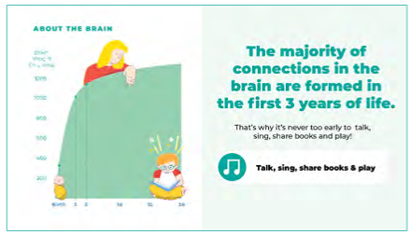**PANEL 3: Brain Growth**

This picture shows the weight of the brain over time. The brain is already gaining weight when a fetus is in utero. Can you see the brain **gains most of its weight between birth and age 3**?

Each synapse that is formed adds weight. People never stop learning. But the curve flattens out because as we grow older most synapses connect to other ones that are already there instead of forming totally new ones.

That’s why what we do with our children in the earliest years makes a difference - because the **foundation of their brains is being built**.

There are **four simple things** we can do to make a difference and give baby the best we can for their **foundation for learning and success in life**.

**1. Talk 2. Sing 3. Share Books 4. Play**

I have a little song we can sing to our babies about how we’ll help them build their learning foundations. It’s on your song sheet.

**It’s called “Talk, Sing, Share Books and Play.”**  ***“Habla, canta, comparte libros, y juega”***

**(*Fee, Fie, Fiddly-ie-oh)***

**Talk, sing, share books and play.** ***Habla, canta, comparte libros, y juega***

**Talk, sing, share books and play.** ***Habla, canta, comparte libros, y juega***

**Talk, sing, share books and play.** ***Habla, canta, comparte libros, y juega***

**Talk, sing, share books and play. -Hooray!** ***Habla, canta, comparte libros, y juega-¡hurra!***

Let’s try it again together! **\*Repeat\***

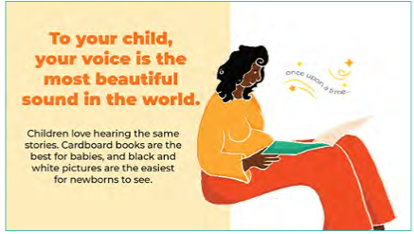**PANEL 4: Sights and Sounds in Books**

Let’s get out another of your take-home gifts – this **black and white board book, *Hello, My World* illustrated by Jannie Ho**. This book and the song sheet are to keep so you can talk, sing, share books and play with your babies now and after they are born.

**Board books** are great for babies because they are **durable** and **easy to clean**. The thick pages stay intact and are easier for babies to **turn** when they are a little bit older.

**\*Point to books for check out* We have more examples for checkout over here.**

Black and white are the easiest colors for newborn babies to see. According to the American Optometric Association, it’s believed babies have good color vision by 5 months old.

When baby is born, there’s so much to see, hear, touch, taste, smell, it’s easy to be overwhelmed. It’s easier to introduce babies to pictures their eyes can see and process more easily. It helps them focus.

But again! Don’t wait until baby is born to start sharing books, you can read to baby right now!

**Let’s go around the circle and each read a page, I’ll start.**

**\*One-by-one read around the circle\***

Fetuses obviously can’t see the pictures, but they can hear sounds as early as 20 weeks. They become used to your voice – the tones and patterns – before they are born.

Once born, babies are comforted by the voices they recognize AS WELL AS the stories and songs repeated to them before they were born. By choosing a special book or song (or more) to **repeat**, you are creating a **familiar, comforting ritual.** Rituals are often comforting for babies.

HERE I WANT TO BE CLEAR about something people may be wondering. No matter what your voice sounds like, **TO YOUR CHILD IT IS THE MOST BEAUTIFUL SOUND IN THE WORLD.** Very young babies are able to pick out their parents’ voices from others.

They love to hear you. Sharing books, songs, stories, and rhymes before they are born not only **builds connection with you**, but also it builds language and early literacy skills – **in every language you are using**.

Before they are born, babies don’t learn actual words, but they can recognize speech patterns and tones and notice when they are from different languages. Babies as young as 2-days-old prefer the language/s they heard their parents speaking and singing when they were still in the womb. So don’t be afraid to speak with your child in more than one language – **this is a boost to the brain and increases those synapses!** Research shows a strong foundation in any language helps learning in other languages, too.

Lifelong learning and reading develops from the very beginning.

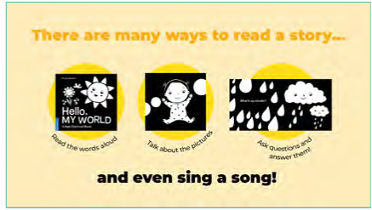**PANEL 5: Many Ways to Share Books**

There are so many ways to share books.Many think the best way to use books with babies is to read them aloud, start to finish, but usually babies don’t have the attention span for an entire book.

**What are other ways we can share books with baby?**

**\*ASK for volunteer ideas\***

-read just one or two pages

-look at one picture, or trace it with your finger, or talk about it, or all three

-look at one or more pictures upside down

-stand it up and knock it over

-sing the book to a familiar tune

*Show 2nd page* For example, the second page reads, “What’s going on bird?” But instead of reading the words you can talk about the picture instead – Here's a bird, two legs, one wing here and another there. Is that bird smiling? I think so. Is she happy? She looks happy. Maybe she’s happy because she’s looking at you! Or talk about the checkboard colors/shapes and a memory like I used to play checkers with my grandpa.

Connecting the pictures in books with words for everyday things around us gives them building blocks for communication. That’s why talking about the pictures is another important way to share books.

**It’s not always easy to think of what to say, so let’s practice it right now.**

Choose a page and **describe what you see** OR **tell about a nice memory it brings up.** No need to be embarrassed, everyone will be doing it at the same time, so we’re not paying attention to each other. I will too, for about two minutes. **\*Individually practice talking about pictures\***

**\*ASK REFLECTION QUESTIONS\*** - Has anyone done that before – not reading the book, but talking about the pictures? Was it easy today? Did you like doing it?

By sharing books with your baby now, you’ll get more comfortable with it. You may even get favorite pages! Your baby will become familiar with the sounds too, so when they are born, these **favorite books will be an additional way to comfort them when they need calming**.

Don’t be surprised if baby seems extra attentive or happy when you repeat the way you read and described pictures before they were born. Children love repetition and learn from it.

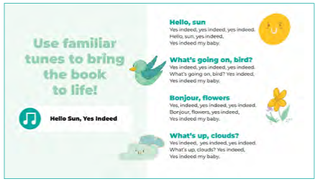**PANEL 6: Hello, Sun, Yes Indeed**

**Now together, let’s try singing the words to the book to the tune I sang at the beginning.**

So instead of Hello Everybody, yes indeed, we’ll sing Hello sun, yes indeed. **\*SING BOOK**  **TOGETHER\***

**Now let’s do What’s going on bird? Yes indeed. One more, Bonjour flowers, yes indeed.**

We hope you’ll enjoy using your books at home in all these ways too. **Sharing books for even a few minutes each day builds strong language skills and a love of learning – and a special connection with you** for many wonderful memories together.

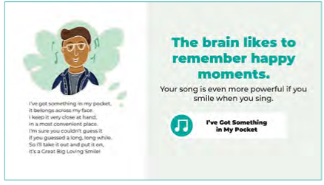**PANEL 7: Happy learning experiences**

Once baby is born, they can do more than hear and feel you – they can see you too! They will delight in looking at your face, especially when you are looking back and smiling.

Here’s a playful song about smiling. If you like it and sing it now, it can be a fun one to continue once baby is born.

**It’s called “I’ve got something in my pocket”**

**I’ve got something in my pocket, it belongs across my face.**

**I keep it very close at hand, in a most convenient place.**

**I’m sure you couldn’t guess it if you guessed a long, long while.**

**So I’ll take it out and put it on, it’s a Great Big Loving Smile!**

**\*Repeat together\***

***“Tengo algo en mi bolsillo”***

***Tengo algo en mi bolsillo, forma parte de mi cara.***

***La mantengo siempre cerca, adivinen qué será.***

***Si ya lo adivinaron, si ya saben lo que es,***

***La saco y me la pongo, es una Gran Sonrisa!***

Why is it important to smile at your babies and create happy experiences with them? It feels good for both of you, #1. And #2 studies show that **children learn best when they feel happy and safe.**

Even now, your loving voice and positive emotions can be felt. You might notice a lot of words in our songs include love and positivity. **These joyful experiences help form a strong learning foundation for your child because their brain WANTS to remember them.**

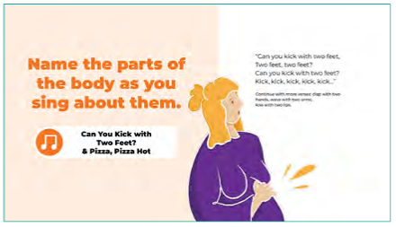**PANEL 8: Name Body Parts**

Young babies also love to look at their own body parts moving. They can’t control their movements at first, but enjoy them anyway – the kicking, waving, wiggling. Naming the body parts and how they move are fun and useful vocabulary.

In fact, if you are the pregnant parent, you could do movements as you name them and might feel your baby’s movements increasing, too, while you sing or dance around.

Let’s try it with this song, it’s especially fun to sing when you feel your baby kicking from inside!

**It’s called “Can You Kick With Two Feet.”**

**\*Act out song\***

**Can you kick with two feet, two feet, two feet?**

**Can you kick with two feet? Kick, kick, kick, kick, kick.**

**Clap with two hands, Wiggle your fingers,...**

***“Patea con dos pies”***

***Patea con dos pies, dos pies, dos pies.***

***Patea con dos pies, Patea, patea, patea.***

***Aplaude con dos manos, Mueve los dedos,...***

**You can always change the words with songs, make it up to do what you want! Sway, blink, stretch...**

**Rhymes:** If you’re not in the mood to sing, try a rhyme instead. Clapping the beat makes it even more playful.

In honor of pregnancy food cravings, here’s an updated version of Peas Porridge Hot:

**It’s called “Pizza, Pizza Hot.”**

**Pizza, pizza hot. Pizza, pizza cold.**

**Pizza, pizza in the box, nine days old.**

**Some like it hot. Some like it cold.**

**Some like it in the box, nine days old.**

Baby still gets to hear you and enjoy the rhythm.

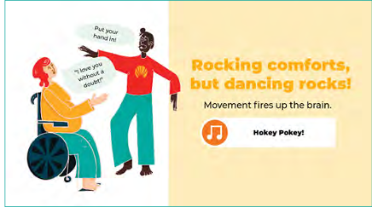**PANEL 9: Hokey Pokey**

**Raise your hand if you like dancing. I love dancing.**

Moving to music is amazing exercise and feels great when it’s music you love. Babies often enjoy being rocked and swayed because it reminds them of being in the womb. It’s comforting.

**Knowing a few songs makes it easy to sing and dance with your baby anytime you want.**

Anyone here know the Hokey Pokey? This is a fun one because as kids get older they like to learn it, too.

If you want to stand up and join in, great, or feel free to stay seated if you’d rather and maybe do the motions from your seat if you can. The words are changed at the end of the song to send a little love message to your baby.

**Let’s sing “The Hokey Pokey”**  ***(Spanish translation on song sheet)***

**You put your RIGHT HAND in, your take your right hand out.**

**You put your right hand in and you shake it all about.**

**You do the Hokey Pokey and you give a little shout:**

**I love you without a doubt! Hug!**

**\*Repeat for LEFT HAND.\***

Of course, no need to limit yourself to children’s songs! Any song is good as long as you like it. The more the merrier.

Combining music and movement together with your babies is so nourishing, it is like giving food to their brain.

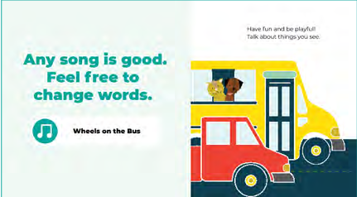**PANEL 10: Songs can be changed**

**No songs are set in stone.** You can sing them how you want and with whatever words you want! If you learn one song, you’ve got song material for every day of the year. Anything can be a song.

“The Wheels on the Bus” is a song many people know. Since we’re at the library, we can sing the last line as “On our way to the library.” Let’s sing it twice with hand movements. Join in whenever you’re ready.

**This is called, “The Wheels on the bus go ‘round and ‘round,’”** ***(Spanish translation on song sheet)***

**The wheels on the bus go ‘round and ‘round,’**

**‘Round and ‘round, ‘round and ‘round.’**

**The wheels on the bus go ‘round and ‘round,’**

**On our way to the library.**

If you’re on your way to give birth, maybe you sing, On our way to the birth center, or hospital, or home!

Once baby is born, you might notice they love animals and change the lyrics again to an animal song. **Maybe I see a cat so I’ll sing,**

**The cat that I see goes, “Meow, meow, meow,”**

**“Meow, meow, meow...Meow, meow, meow.”**

**The cat that I see goes, “Meow, meow, meow,”**

**All day long!**

*Show puppy page from book* Here’s a puppy let’s sing it as the puppy that I see goes woof.

The puppy that I see goes, “Woof, woof, woof,”

“Woof, woof, woof...Woof, woof, woof.”

The puppy that I see goes, “Woof, woof, woof,”

All day long!

Maybe you’re changing a diaper, or splashing in a bath...Any words work, you get the picture!

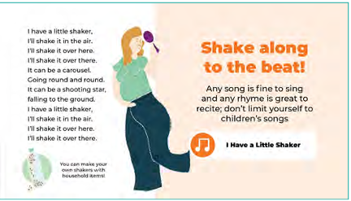**PANEL 11: Shakers**

Lots of simple items can be turned into instruments.

**Is anyone here a musician? What do you play?**

*Show water bottle with rice* Here’s a water bottle with rice. It makes a nice sound when I shake it. Think about some other ways you could make a shaker. Because safety is of the utmost importance, it’s best to show your baby’s pediatrician a homemade shaker before giving it to your baby.

For today we have some shaker toys we can use. *HAND OUT SHAKERS* Since these are small and make a soft sound, they are great for little babies.

I can’t send them home this time, **but!** As a follow-up to this class once your babies are born, we will be offering a different class in the fall called **Hatchlings: In the Nest that you are invited to join with your baby.** Shakers like these are one of the gifts we can send home when you join that class.

Let’s do a little shaker song. We’ll sing and act it out twice, feel free to join in when you’re ready. It’s a similar tune to the smile song.

**It’s called “I have a little shaker”**

**I have a little shaker, I’ll shake it in the air.**

**I’ll shake it over here, I’ll shake it over there.**

**It can be a carousel, going round and round.**

**It can be a shooting star, falling to the ground.**

**I have a little shaker, I’ll shake it in the air.**

**I’ll shake it over here, I’ll shake it over there.**

**NOW Let’s stand up if you’d like and be as silly/dramatic as we want this time.** Best to share songs in whatever way you enjoy.

**\*Repeat song.\***

Thanks everyone. I’ll collect these shakers for now. *COLLECT SHAKERS*

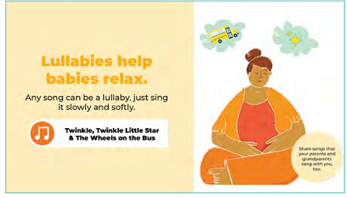**PANEL 12: Lullabies**

Sometimes you or your baby or both of you are too tired to dance. After this whole class of moving, let’s sing a lullaby.

The **soft, slow pace of lullabies helps both you and your baby to relax.** Remember that babies remember the songs you sing or hum to them before they are born and can be very comforted by hearing them after they are born.

All babies have their cranky moments, so having a lullaby at the ready is essential.

**Let’s do “Twinkle Twinkle Little Star.” Join in as you’re ready.**

**Twinkle, twinkle, little star.**

**How I wonder what you are.**

**Up above the world so high,**

**Like a diamond in the sky.**

**Twinkle, twinkle, little star.**

**How I wonder what you are.**

Let’s do it again, but this time in Spanish called “Estrellita.” You could sing along with your song sheet or hum. **Humming can be very soothing**. And let’s sway or rock from side-to-side a little.

**Let’s do “Estrellita, ¿dónde estás?”**

**Estrellita, ¿dónde estás?**

**Me pregunto que serás.**

**En el cielo y en el mar**

**Un diamante de verdad**

**Estrellita, ¿dónde estás?**

**Me pregunto que serás.**

Maybe you remember a lullaby your parents or grandparents sang with you? It’s **wonderful to pass down traditional songs and stories that have been part of your family’s history and culture**.

Of course, really any song can be a lullaby as long as you sing it slowly and softly.

Let’s demonstrate with “The Wheels on the Bus” from earlier. Let’s all take two deep breaths in and out. **If you wish, close your eyes and sway.**

**The wheels on the bus go ‘round and ‘round,’**

**‘Round and ‘round, ‘round and ‘round.’**

**The wheels on the bus go ‘round and ‘round,’**

**On our way to the library.**

Lullabies help babies AND parents relax.

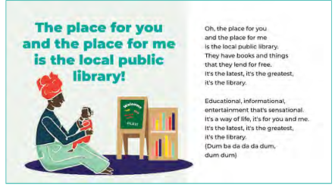**PANEL 13: Libraries**

Thank you so much for being here with us today. Classes like these are part of our library’s mission – high-quality public education for all. We have many free family classes for all ages, with songs, rhymes, stories, and more. Take a look in your gift bundle for the calendar of classes as an example. **I’ve highlighted the classes for new babies with their grownups.**

When you and your new baby are ready, we’d love to see you again in these classes. They are a great way to find n**ew ways to play with your baby** and also to **meet other new parents**. No need to worry about babies making noise either, libraries are no longer SHUSH ZONES. We have play areas and classes full of music and love seeing families playing here together.

Plus, anyone **can get a library card and borrow books, toys, movies, music, and more**.

*Check out this display and borrow any of these items today.*

We always have library staff ready to help you find what you are looking for. That’s our job!

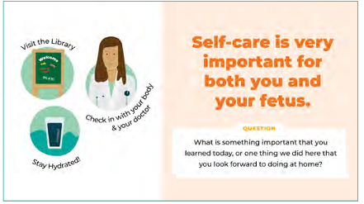**PANEL 14: Self-Care**

The library also has books about pregnancy, some you’ll see here. **To be clear, library staff are not health professionals. But, we can help you find books and resources to help you learn more about pregnancy and babies, and what you might need for your own self-care.**

**Self-care is so important. Would anyone like to share a self-care strategy that has helped them?**

**\*Allow space for answers\*** Thank you.

Before and after baby is born, especially right after, be sure to be in touch with your doctor for any health or wellbeing concerns, that includes emotional concerns too.

For any questions about resources here in the library or in the community, please know you are always welcome to ask me or any of my library colleagues.

You don’t need to wait until your baby is born to visit me again here at the library. But it would also be especially wonderful to come by with your baby and say Hello. I’d love to meet them 😊

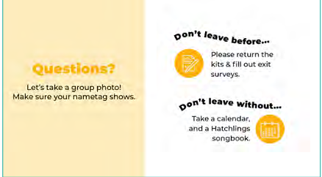**PANEL 15: Questions & Closing**

Does anyone have a **question or questions** about anything we’ve done or discussed today?

**\*Allow space for answers\*** Thank you.

In the meantime, who would like to share **something important that you heard today**, or one thing we did here that you **look forward to also doing at home**?

This Hatchlings Ready to Hatch class was designed especially for parents-to-be. We’ll be offering this same session again at different locations. Please check out the **flyer in your bundle.** You are welcome to return although the content will be the same.

Then, in the fall, there will be a new continuation of this program. It’s called Hatchlings In the Nest, you have a **miniflyer in your bundle**. It will take place at a Howard County Library branch - dates and location will be announced, but it will be a series: once a week for four weeks. It’s designed for parents and caregivers and their babies birth - 4 months old. Since you’ve attended this Ready to Hatch class, you’re invited even if your baby is not exactly in the age range. In addition to the **joy of doing fun activities with your baby**, it’s a great chance to **connect with other parents too**.

*Show ITN example gift kit* PLUS, Over the course of the four-class series of Hatchlings In the Nest, you’ll receive an entire kit as a take-home gift. There’s a **frog puppet**, a **shaker**, an **indestructible book** with beautiful animal pictures, and a **songbook** with more and different songs, a day-by-day **activity calendar** from the MD State Library if you don’t already have one, and this **handy tote bag** to hold it all!

As a health note – Many pediatricians recommend waiting until a baby is a couple of months old before spending time in public, especially during cold and flu season. **So please do check with your pediatrician before bringing baby to our In the Nest class.**

We are coming to the end of our session. I hope it’s been fun and helpful.

**With your permission, I’d like to ask if we can take a quick group photo** to help document and develop our program.

**\*\*GROUP PHOTO\*\*** Thank you.

**\*Handout Surveys\*** Since Hatchlings is a new class, we’d love to know what you thought about it. Your honest feedback helps us improve the class so we can make it even better.

Just before you complete these, let’s end with our song about the easy things you can continue to do to give your baby a great start, even before birth and following that. Join me in singing if you like!

**Talk, sing, share books and play.** ***Habla, canta, comparte libros, y juega***

**Talk, sing, share books and play.** ***Habla, canta, comparte libros, y juega***

**Talk, sing, share books and play.** ***Habla, canta, comparte libros, y juega***

**Talk, sing, share books and play. -Hooray!** ***Habla, canta, comparte libros, y juega-¡hurra!***

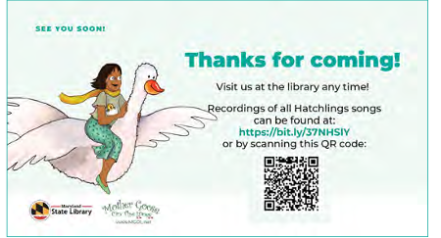**PANEL 16: Goodbyes**

Thanks for coming, everybody!

There is a QR code up here and on your song sheet with recordings of all of today’s songs.

**Completed surveys can be left on the sign-in table.**

After you finish your surveys, **please feel free to stay awhile and talk more with each other or check in with any questions you might have.**

Thank you again for being here today.